Project Design Phase-II
Data Flow Diagram & User Stories

Date | 19 February 2026
Team ID | LTVIP2026TMIDS62229
Project Name | Exploratory Analysis of Rain Fall Data in India for Agriculture
Maximum Marks | 4 Marks

Data Flow Diagrams:
A Data Flow Diagram (DFD) is a traditional visual representation of the information flows within a system. A neat and clear DFD can depict the right amount of the system requirement graphically. It shows how data enters and leaves the system, what changes the information, and where data is stored.

Example: (Simplified)

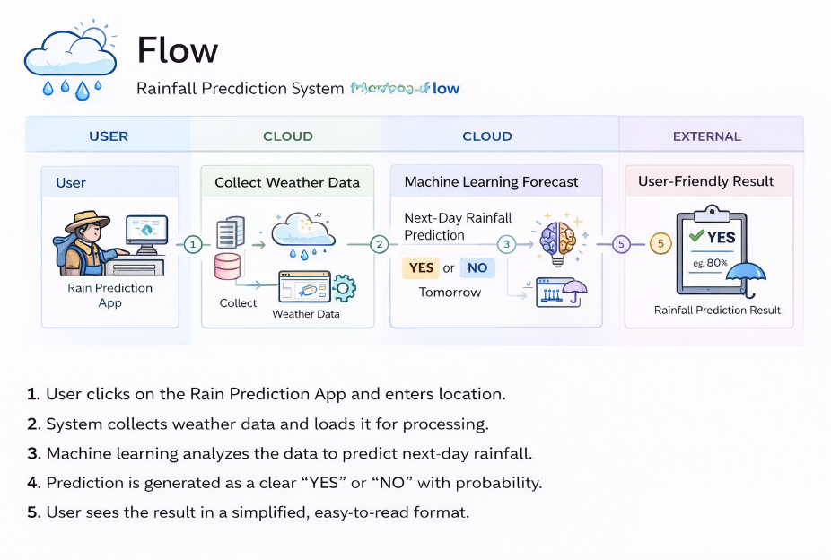
User Stories
User Type | Functional Requirement (Epic) | User Story No | User Story / Task | Acceptance Criteria | Priority | Release
Customer (Web User) | Weather Data Input | USN-1 | As a user, I can enter MinTemp, MaxTemp, Rainfall, WindGustSpeed, and Humidity3pm values. | All input fields accept valid numerical values and allow submission. | High | Sprint-1
Customer (Web User) | Rainfall Prediction | USN-2 | As a user, I can click Predict to know whether it will rain tomorrow. | System displays prediction result (Rain / No Rain). | High | Sprint-1
Customer (Web User) | Probability Display | USN-3 | As a user, I can see the rainfall probability percentage. | Prediction shows probability (e.g., 66%). | High | Sprint-1
Customer (Web User) | Input Validation | USN-4 | As a user, I get an error message if I enter invalid or empty values. | System prevents submission and shows validation error. | High | Sprint-1
Customer (Web User) | User Interface | USN-5 | As a user, I can access a simple and responsive web interface. | Web page loads correctly and is user-friendly. | Medium | Sprint-2
System | Model Training | USN-6 | System trains ML model using selected weather features. | Model achieves acceptable accuracy and saves successfully. | High | Sprint-1
System | Model Deployment | USN-7 | System loads trained model (.pkl) for predictions. | Model loads without error and gives output. | High | Sprint-1
Administrator | Model Update | USN-8 | As an admin, I can retrain and update the model. | Updated model works correctly after replacement. | Medium | Sprint-2
System | Performance | USN-9 | System provides prediction within short time. | Prediction result appears within 2 seconds. | Medium | Sprint-2
Customer (Web User) | Deployment | USN-10 | As a user, I can access the application through browser. | Application runs on localhost/server without errors. | Medium | Sprint-3

